TQS: Product specification report
Ana Ribeiro [119876], Gonçalo Almeida [119792], João Barreira [120054], Rodrigo Santos [119198]
v2025-11-21

1 Introduction 1
1.1 Overview of the project 1
1.2 Known limitations 1
1.3 References and resources 2
2 Product concept and requirements 2
2.1 Vision statement 2
2.2 Personas and scenarios 2
2.3 Project epics and priorities 2
3 Domain model 3
4 Architecture notebook 3
4.1 Key requirements and constrains 3
4.2 Architecture view 3
4.3 Deployment view 3
5 API for developers 3

Introduction

Overview of the project
This project assignment for the Teste e Qualidade de Software (TQS) course serves as a practical application of the knowledge and concepts acquired throughout the semester, with emphasis on Agile development methods, Software Quality Assurance, continuous integration and delivery approaches.

Party Share is a simple and convenient marketplace designed to facilitate the rental of party-related equipment such as lighting and sound equipment, furniture and party-related machines that often sit unused. The platform connects item owners who want to earn extra income with people looking to rent what they need for a specific event.

For owners, Party Share is an easy way to earn money from equipment that would otherwise stay stored most of the time. For renters, it makes finding the right items for birthdays, weddings, and all kinds of events much easier and intuitive, without needing to buy expensive equipment they’ll only use once.

The goal is to make the rental process smooth, quick, and trustworthy for both sides, providing a unified platform where browsing, booking, and interacting all happen in the same place.

Project limitations and know issues
<explain the known limitations, especially the features that were planned/expected but not implemented (and why…)

To be reviewed and completed by the end of the project >

References and resources
<document the key components (e.g.: libraries, web services) or key references (e.g.: blog post) used that were really helpful and certainly would help other students pursuing a similar work>

Product concept and requirements

Vision statement
Party Share aims to solve the problem of expensive, wasteful, and inefficient access to party equipment by offering a peer-to-peer rental marketplace dedicated to event items.
The system focus is making it easy for renters to discover and rent needed items, while decreasing the usability friction for owners, to make them generate income from equipment they already have.
The high-level goal of Party Share is to reduce waste, increase access and bring transparency to the rental process.

To achieve this, the following key features are:
- Item Discover: A searchable catalog of party equipment, with filters and favorites;
- Booking & Availability Management: Booking requests with conflict-free reservations;
- Private Communication: Message chat between Renter and Owner
- Role-Based Access: Distinct dashboards for Owners, Renters and Admins
- Administration Tools: User & Categories management, Platform Monitoring

The solution differentiates itself by focusing specifically on event/party equipment, offering useful structured item categories to facilitate the event planners’ and casual party organizers’ job.

Personas and scenarios
    - Personas
Paulo, 38 - Accountant [Casual Renter]

Paulo lives in a quiet suburban neighborhood and enjoys hosting casual gatherings, family barbecues, and birthday parties in his backyard. He likes making these moments special, but as someone very mindful of budgeting, he avoids buying equipment that he knows he will use only once or twice a year. Although comfortable with technology, Paulo loses patience with platforms that feel confusing, unreliable, or that bury essential information behind too many steps.

Motivations
- Spend less by renting instead of purchasing rarely-used items.
- Find all equipment for a party in a single, well-organized platform.
- Easily compare items based on price, distance, availability, and category.
- Plan events quickly thanks to intuitive search and filtering.

Pain Points
- Buying party items feels financially wasteful due to low usage frequency.
- Local stores often have limited stock and offer little item variety.
- Comparing prices and availability across different websites / stores is time-consuming.
- Worries about renting damaged items or dealing with unreliable owners.

Sofia, 25 - Pastry Artist & Event Caterer [Frequent Renter]

Sofia is a talented pastry artist who turned her passion for baking into a small business. She creates custom desserts for birthdays, weddings, and corporate events, and also organizes baking workshops. Although highly creative and skilled, she lacks the storage space and financial capacity to own all the professional furniture and equipment she needs for different events.
Pain Points
- She frequently needs the same (or similar) items she cannot justify buying.
- Seasonal demand means equipment bought would often stay unused for long periods.
- Renting through traditional companies is expensive and rigid (minimum rents, long-term commitments).
- Last-minute client requests make it difficult to plan with fixed or rigid providers.

Motivations
- Access to professional equipment whenever needed, without long-term commitments.
- Quickly verify item availability for specific event dates to ensure smooth planning.
- Save frequently rented items to a favorites list for faster repeat bookings.
- Rely on transparent pricing, trustworthy ratings and detailed item photos.
- Communicate directly with item owners through in-app messaging.

    - Scenarios
      - Scenario 1: Paulo Rents an Item for a Weekend Barbecue
Paulo is organizing a small barbecue for his family and needs a portable speaker to set the mood. He opens Party Share, searches for sound equipment, and compares items based on price, ratings, and distance. After reading reviews, he messages the owner to confirm pickup time and place. Satisfied with the details, Paulo proceeds with the booking.

Actions:
- Opens the Party Share platform
- Searches for sound equipment
- Applies filters to narrow down options
- Identifies a suitable speaker
- Checks item details and photos
- Checks ratings and reads reviews
- Sends a message to the item owner inquiring about pickup details
- Inputs preferred rental dates
- Books the item

      - Scenario 2 – Paulo Rates the Item and the Owner After Returning It
After the barbecue, Paulo returns the speaker and is satisfied with both the quality of the item and the responsiveness of the owner. Wanting to help other renters, he logs in to PartyShare, visits his past bookings, and leaves a rating for both the item and the owner. He adds a short comment highlighting the good condition of the speaker and the smooth communication. With this, Paulo closes the renting cycle feeling confident to use the platform again.

Actions:
- Logs into PartyShare
- Opens the “Past Rentals” section
- Selects the completed booking
- Rates the item
- Rates the owner
- Submits a written comment

      - Scenario 3 – Sofia Rents an Item from Her Favorites List
Sofia is preparing a dessert workshop and needs extra folding tables. She opens PartyShare and navigates to her favorites list, where she keeps the items she rents most often. She selects the folding tables she trusts, since she already knows the owner and the item’s quality. She checks the availability for the workshop date and confirms the rental.

Actions:
- Opens PartyShare on her phone
- Navigates to the favorites tab
- Selects the frequently rented item
- Checks date availability
- Confirms the booking

      - Scenario 4 – Sofia Cancels a Rental Due to Weather Issues
Sofia has an outdoor catering event scheduled, but unexpected heavy rain forces her client to cancel. To avoid unnecessary expenses, she opens her upcoming rentals in the app, selects the rented lighting equipment for that event, and submits a cancellation request, after reviewing the cancellation policy. She may also contact the owner through the chat to apologize for the inconvenience and explain the situation.

Actions:
- Opens the upcoming rentals section
- Selects the affected booking
- Reviews the cancellation policy
- Submits the cancellation request
- Sends a message to the owner to explain the situation

<“Personas are fictional people. They have names, likenesses, clothes, occupations, families, friends, pets, possessions, and so forth. They have age, gender, ethnicity, educational achievement, and socioeconomic status. They have life stories, goals and tasks. Scenarios can be constructed around personas, but the personas come first. They are not ‘agents’ or ‘actors’ in a script, they are people. Photographs of the personas and their workplaces are created and displayed. […] It is to obtain a more powerful level of identification and engagement that enable design, development, and testing to move forward more effectively”. Adapted from Grudin, J. and Pruitt, J., 2002, June. Personas, participatory design and product development: An infrastructure for engagement. In Proc. PDC (Vol. 2).
Sample personas: secção 4.1, neste artigo (open access)] >

<Develop one or more representative scenarios for each persona. You don’t need to include all possible details. Pick the main scenarios, related to the core value of the system.>
<The scenarios tell the story of the Personas in their lives, doing their daily/professional activities that are relevant to find the points of contact with the system under specification.
Scenarios are somewhat similar to use cases (they have a goal and tell a story), but, unlike use cases, they capture a larger process, with activities that may not use the software. Scenarios don’t require a “template”, like the usual use cases description.>
Sample: secção 4.2 neste artigo (open access)] >

Project epics and priorities
[Apresentar um plano indicativo para a implementação incremental da solução ao longo de várias iterações/releases, explicando as funcionalidades a atingir por epics ]

Domain model
<which information concepts will be managed in this domain? How are they related?>
<use a logical model (UML classes) to explain the concepts of the domain and their attributes, not a entity-relationship relational database model>

Architecture notebook

Key requirements and constrains
The architecture of PartyShare is shaped by functional expectations, quality attributes, and external system interactions. The platform must support a smooth rental experience while ensuring security, scalability, and reliable communication between users.

    - Functional Constraints

      - Multi-role platform (Renter, Owner, Admin)
The system must support different types of users, each with distinct permissions and interactions. This requires a role-based access control mechanism.

      - Real-time booking and availability management
The system must ensure that items cannot be double-booked and that availability updates propagate consistently.

      - Messaging between users
The system must include a private conversation and messaging service between users. It stores the messages in a structured model.

      - Integration with external payment providers
The platform must integrate with third-party payment systems (e.g., Stripe Sandbox). This requires isolating external API calls, failure handling, and ensuring secure communication.

    - Quality Constraints
      - Scalability
The platform must support growth in the number of users, items, and bookings without degradation in performance. Horizontal scalability through stateless services is encouraged.

      - Maintainability
A clear layered architecture (presentation - services - persistence) isolates responsibilities, simplifies maintenance and enables testing for each layer individually.

      - Reliability
Booking and payment flows must guarantee consistency. The system should be able to recover from errors, ensuring that failed processes can be rolled back safely and do not corrupt data.

<Identify issues that will drive the choices for the architecture such as: Are there hardware dependencies that should be isolated from the rest of the system? Does the system need to function efficiently under unusual conditions? Are there integrations with external systems? Is the system to be offered in different user-interfacing platforms (web, mobile devices, big screens,…)?
For a more systematical approach:
- Note the collection of Architectural Characteristics the software architect should be aware
- Identify architectural characteristics that are relevant for your project (will drive the key design decisions). Note the case study and the explicit characteristics related to users and extensibility. This will support later non-functional tests.

Architecture view
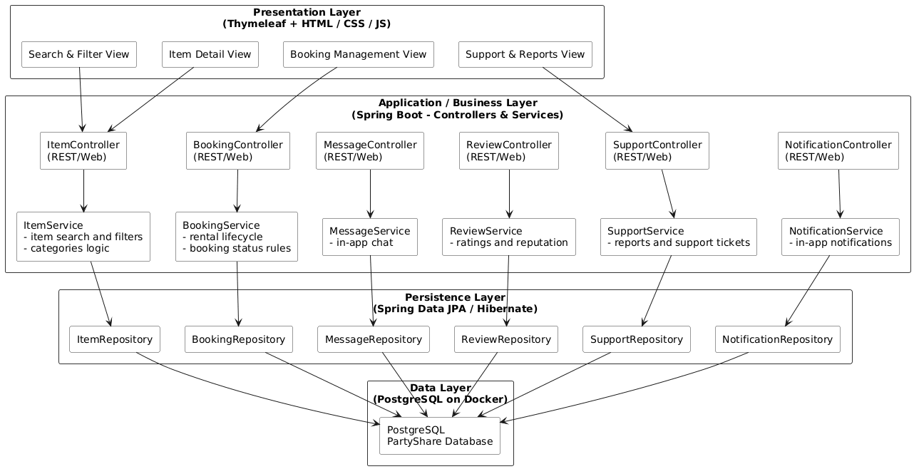

→ Discuss architecture planned for the software solution: what are the main building blocks? include a diagram (a logical view, such as a package or block diagram). Avoid implementation technology or deployment references, but protocols/standards can be included.
→ refer to the architecture style applied, if any
🡪 explain how the identified modules will interact. Use a sequence diagram to clarify the interactions along time, when needed
→ discuss more advanced app design issues: integration with Internet-based external services, data synchronization strategy, distributed workflows, push notifications mechanism, distribution of updates to distributed devices, etc.>

Deployment view (production configuration)
[Explain the planned organization of the solution in terms of production configuration (deployment). Note the implementation technologies in the diagram, e.g.: place the PostgreSQL symbol in the Database, etc.]. Indicate the existence of containers (Docker), IP addresses, and ports, etc.
This part will be completed when deployments are actually in place.

API for developers
[Explain the API organization and main collections in general terms. Details/documentation of methods should be included in a hosted API documentation solution, such as Swagger, Postman documentation, or included in the development itself (e.g., Maven site).
🡪 Be sure to use best practices for REST Api design. Keep minda REST API applies a resource-oriented design (APIs should be designed around resources, which are the key entities your application exposes, not actions)

